REAL TIME OBJECT DETECTION Using

OpenCV

INTRODUCTION

**Real-Time Object Detection**  is a vast, vibrant and complex area of computer vision. If there is a single object to be detected in an image, it is known as Image Localization and if there are multiple objects in an image, then it is Object Detection. This detects the semantic objects of a class in digital images and videos. The applications of real time object detection include tracking objects, video surveillance, pedestrian detection, people counting, self-driving cars, face detection, ball tracking in sports and many more. Convolution Neural Networks is a representative tool of Deep learning to detect objects using Open CV(Opensource Computer Vision), which is a library of programming functions mainly aimed at realtime computer vision

Keywords: **Computer vision, Deep Learning, Convolution Neural Networks.**

**Real-Time Object Detection** is a computer vision task that involves identifying and locating objects of interest in real-time video sequences with fast inference while maintaining a base level of accuracy.

This is typically solved using algorithms that combine object detection and tracking techniques to accurately detect and track objects in real-time. They use a combination of feature extraction, object proposal generation, and classification to detect and localize objects of interest.

Real-time object detection is a crucial aspect of computer vision with applications spanning autonomous vehicles, surveillance, robotics, and augmented reality. This study examines real-time object detection techniques, highlighting their significance in artificial intelligence. The primary goal is swift and accurate object identification in images or video streams. Traditional methods like sliding windows and region-based approaches had limitations in computational efficiency. Deep learning, particularly Convolutional Neural Networks (CNNs), revolutionized object detection. Models like SSD, YOLO, and Faster R-CNN excel in accuracy and speed. They employ anchor boxes, feature pyramid networks, and non-maximum suppression to balance precision and processing speed.

Hardware accelerators like GPUs, TPUs, and FPGAs facilitate real-time inference. Challenges in real-time object detection include occlusion, scale variations, and cluttered environments. Researchers must navigate the trade-offs between accuracy and speed. Real-time object detection is pivotal in computer vision, enabling intelligent systems across diverse applications. The continuous evolution of deep learning algorithms and hardware capabilities pushes the boundaries of this field, making it a dynamic research domain in artificial intelligence.

APPLICATION

The major applications of Object Detection are:

**FACIAL RECOGNITION**

“Deep Face” is a deep learning facial recognition system developed to identify human faces in a digital image. Designed and developed by a group of researchers in Facebook. Google also has its own facial recognition system in Google Photos, which automatically separates all the photos according to the person in the image.

There are various components involved in Facial Recognition or authors could say it focuses on various aspects like the eyes, nose, mouth and the eyebrows for recognizing a faces.

**PEOPLE COUNTING**

People counting is also a part of object detection which can be used for various purposes like finding person or a criminal; it is used for analysing store performance or statistics of crowd during festivals. This process is considered a difficult one as people move out of the frame quickly.

**INDUSTRIAL QUALITY CHECK**

Object detection also plays an important role in industrial processes to identify or recognize products. Finding a particular object through visual examination could be a basic task that's involved in multiple industrial processes like sorting, inventory management, machining, quality management, packaging and so on. Inventory management can be terribly tough as things are hard to trace in real time. Automatic object counting and localization permits improving inventory accuracy.

**SELF DRIVING CARS**

Self-driving is the future most promising technology to be used, but the working behind can be very complex as it combines a variety of techniques to perceive their surroundings, including radar, laser light, GPS, odometer, and computer vision. Advanced control systems interpret sensory info to allow navigation methods to work, as well as obstacles and it. This is a big step towards Driverless cars as it happens at very fast speed.

**SECURITY**

Object Detection plays a vital role in the field of Security; it takes part in major fields such as face ID of Apple or the retina scan used in all the sci-fi movies. Government also widely use this application to access the security feed and match it with their existing database to find any criminals or to detecting objects like car number involved in criminal activities. The applications are limitless.

**OBJECT DETECTION WORKFLOW AND FEATURE EXTRACTION**

Every Object Detection Algorithm works on the same principle and it’s just the working that differs from others. They focus on extracting features from the images that are given as the input at hands and then it uses these features to determine the class of the image

Project Objective

The motive of object detection is to recognize and locate all known objects in a scene. Preferably in 3D space, recovering pose of objects in 3D is very important for robotic control systems. Imparting intelligence to machines and making robots more and more autonomous and independent has been a sustaining technological dream for the mankind.

It is our dream to let the robots take on tedious, boring, or dangerous work so that we can commit our time to more creative tasks. Unfortunately, the intelligent part seems to be still lagging behind. In real life, to achieve this goal, besides hardware development, we need the software that can enable robot the intelligence to do the work and act independently.

One of the crucial components regarding this is vision, apart from other types of intelligences such as learning and cognitive thinking. A robot cannot be too intelligent if it cannot see and adapt to a dynamic environment. The searching or recognition process in real time scenario is very difficult. So far, no effective solution has been found for this problem.

Despite a lot of research in this area, the methods developed so far are not efficient, require long training time, are not suitable for real time application, and are not scalable to large number of classes.

Object detection is relatively simpler if the machine is looking for detecting one particular object. However, recognizing all the objects inherently requires the skill to differentiate one object from the other, though they may be of same type. Such problem is very difficult for machines, if they do not know about the various possibilities of objects.

Motivation

Blind people do lead a normal life with their own style of doing things. But, they definitely face troubles due to inaccessible infrastructure and social challenges. The biggest challenge for a blind person, especially the one with the complete loss of vision, is to navigate around places. Obviously, blind people roam easily around their house without any help because they know the position of everything in the house. Blind people have a tough time finding objects around them. . So we decided to make a REAL TIME OBJECT DETECTION System. We are interested in this project after we went through few papers in this area. As a result we are highly motivated to develop a system that recognizes objects in the real time environment

Platform Used

Hardware

Hardware is a term that refers to all the physical parts that make up a computer. The internal hardware device that make up the computer. Various devices which are essentials to form a hardware is called as components. Following are the hardware specifications that is required to develop this project is as follows:

1. Computer components like Monitor, keyboard, Mouse, CPU, Webcam
2. Minimum 1 GB ram fro smooth working of application.
3. 250 GB hard disk or more. CD ROM DEVICE.

Software

Software is a set of instructions, data or programs used to operate computers and execute specific tasks. It is the opposite of hardware, which describes the physical aspects of a computer. Software is a generic term used to refer to applications, [scripts](https://www.techtarget.com/whatis/definition/script) and programs that run on a device. It can be thought of as the variable part of a computer, while hardware is the invariable part.

Software Used:

PyCharn Community : The IDE for Pure Python Development.

In Built Camera : version 2023.2312.3.0 / External Webcam

Operating System:

Windows 10 Pro : Version : 22H2, OS build : 19045.4412

Processor :Intel(R) Core(TM) i3-7100U CPU @ 2.40GHz 2.40 GHz

PROJECT MODULES

MODULES USED :

1. NumPy :

NumPy is a general-purpose array-processing package. It provides a high-performance multidimensional array object and tools for working with these arrays. It is the fundamental package for scientific computing with Python. It is open-source software.

1. OpenCV :

Open CV stands for open source computer vision. it's a group of libraries in Python. it's a tool by which we will be able to manipulate the pictures , like image scaling, etc.

This supports and helps us in developing real time computing applications.

It mainly concentrates and targets on image processing, video capture and analysis. It includes several features like face detection and also object detection.

` Currently OpenCV supports differing types of programming languages like C++, Python, Java etc., and it's available on various platforms including Windows, Linux, OS X, Android etc.

OpenCV was designed to be cross-platform. So, the library was written in C and this makes OpenCV portable to almost any commercial system, from PowerPC Macs to robotic dogs. Since version 2.0, OpenCV includes its traditional C interface as well as the new C++ one. For the most part, new OpenCV algorithms are now developed in C++. Also wrappers for languages such as Python and Java have been developed to encourage adoption by a wider audience. OpenCV runs on both desktop (Windows, Linux, Android, MacOS, FreeBSD, OpenBSD) and mobile (Android, Maemo, iOS).

3. CNN:

The convolutional neural network, or CNN for brief, could also be a specialized kind of neural network model designed for working with two-dimensional image data, although they're going to be used with one-dimensional and three-dimensional data.

Central the convolutional neural network is the convolutional layer that gives the network its name. This layer performs an operation known as “convolution”.

PROJECT TYPE

Real time object detection is a vast, vibrant and complex area of computer vision. Ifthere is a single object to be detected in an image, it is known as Image Localization and ifthere are multiple objects in an image, then it is Object Detection. This detects the semanticobjects of a class in digital images and videos.

In recent times, the field of artificial intelligence has been revolutionized by remarkable advancements, particularly in the domains of computer vision and deep learning. One of the most noteworthy applications of these technologies is in the realm of object detection, a task that was once deemed exceedingly challenging but has now become significantly more accessible.

With the aid of cutting-edge machine learning algorithms and neural networks, computer systems have made significant strides in object tracking in computer vision. By analysing vast amounts of visual data, these algorithms can detect and classify objects within images and videos with increasing accuracy and speed. From self-driving cars to security cameras, object detection has proven to be an essential component of many advanced technologies, shaping our world in ways once deemed impossible.

**Object Detection in Computer Vision**

It serves to identify, locate, and categorize objects in both digital images and real-world scenarios. It represents an applied artificial intelligence approach, whereby computers are endowed with the ability to perceive and interpret the visual world in a manner akin to human beings. Object detection applications are marvel of modern technology, whereby machines are trained to identify and understand the characteristics of objects, and then apply that understanding to a variety of tasks. These tasks may include everything from identifying traffic signs on a busy road, to recognizing the faces of individuals in a crowd.

By leveraging advanced machine learning algorithms and neural networks, object detection process can analyse and processing vast amounts of visual data. This data is used to train the system to recognize and classify objects with increasing levels of accuracy and efficiency. In essence, object detection provides computers with the ability to see and understand the world around them, in ways that were once thought to be the sole province of human beings. Today, object detection is a rapidly evolving field that holds great promise for a wide range of applications, from self-driving cars to robotics, healthcare, [manufacturing industry](https://pluto-men.com/computer-vision-in-manufacturing/) and security. By enhancing our ability to interpret and understand the visual world, object detection is paving the way for a new era of innovation and technological progress.

SYSTEM DESIGN

1. DFD- DATA FLOW DIAGRAM

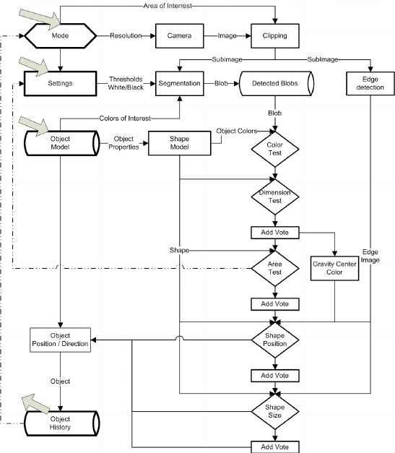

1. ACTIVITY DIAGRAM

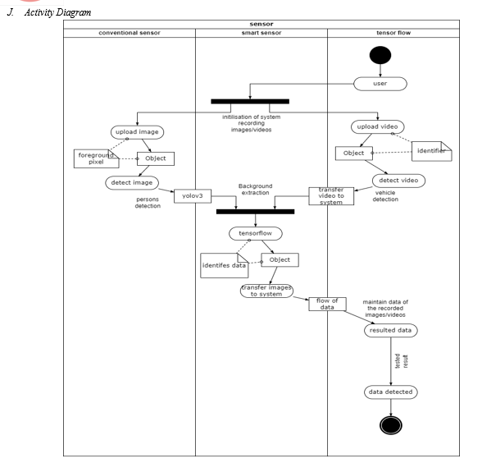

1. SEQUENCE DIAGRAM

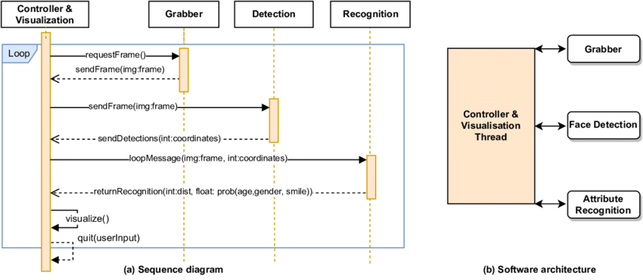

1. ER DIAGRAM

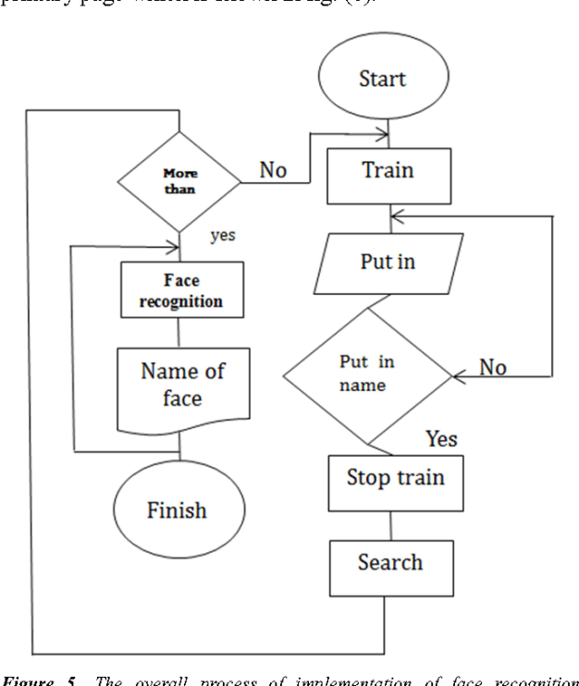

1. BLOCK DIAGRAM

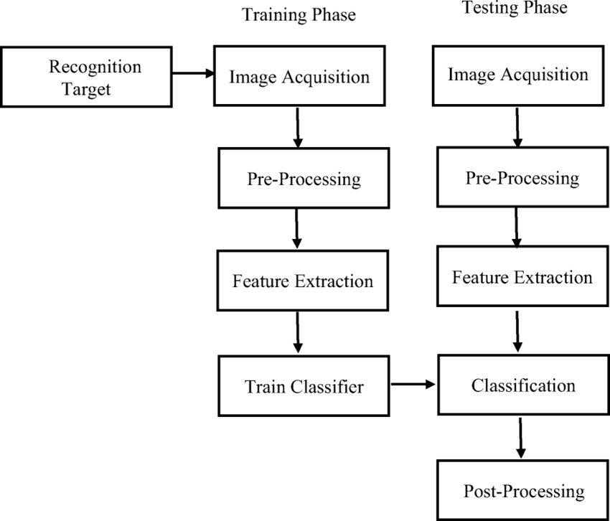

CONCLUSION

Deep-learning based object detection has been a search hotspot in recent years.

This project starts on generic object detection pipelines which give base architectures for other related tasks. With the assistance of this the 3 other common tasks, namely object detection, face detection and pedestrian detection, are often accomplished.

Authors accomplished this by combing 2 things: Object detection with deep learning and OpenCV and Efficient, threaded video streams with OpenCV.

The camera sensor noise and lightening condition can change the result because it can create problem in recognizing the objects.Generally, this whole process requires GPU’s rather than CPU’s. But we’ve done using CPU’s and executes in much less time, making it efficient.

Object Detection algorithms act as a mixture of both image classification and object localization. It takes the given image as input and produces the output having the bounding boxes adequate to the amount of objects present within the image with the category label attached to every bounding box at the highest. It projects the scenario of the bounding box up the shape of position, height and width.

LIMITATIONS

It's important to note the limitations of object detection so you can avoid or mitigate the effects of false negatives (missed objects) and limited detail.

* Objects are generally not detected if they're small (less than 5% of the image).
* Objects are generally not detected if they're arranged closely together (a stack of plates, for example).’
* Objects are not differentiated by brand or product names (different types of sodas on a store shelf, for example). However, you can get brand information from an image by using the [Brand detection](https://learn.microsoft.com/en-us/azure/ai-services/computer-vision/concept-brand-detection) feature.

## 6 Problems with Object Detection

1. Viewpoint Variation: An object viewed from different angles may look completely different.

### Deformation: Many objects of interest are not rigid bodies and can be deformed in extreme ways.

### Occlusion: The objects of interest can be occluded. Sometimes only a small portion of an object (as little as a few pixels) may be visible.

### Illumination Conditions: The effects of illumination are drastic on the pixel level. Objects exhibit different colors under different illumination conditions.

### Cluttered or Textured Background: The objects of interest may blend into the background, making them hard to identify.

### Intra-Class Variation: An object of interest can often be relatively broad, such as a house. There are many different types of these objects, and each will have its own distinct appearance.

### FUTURE SCOPE

### Here are a some of the future implementation of object detection.

### 1. Face detections and recognition: Face detection perhaps be a separate class of object detection. We wonder how some applications like Facebook, Faceapp, etc., detect and recognize our faces. This is often a sample example of object detection in our day to day life. Face detection is already in use in our lifestyle to unlock our mobile phones and for other security systems to scale back rate .

### 2. Object tracking: Object detection is additionally utilized in tracking objects like tracking an individual and his actions, continuously monitoring a ball within the game of Football or Cricket. As there's an enormous interest for people in these games, these tracking techniques enables them to know it during a better way and obtain some additional information. Tracking of the ball is of maximal importance in any ball-based games to automatically record the movement of the ball and adjust the video frame accordingly.

### 3. Self-driving cars: This is often one among the main evolutions of the planet and is that the best example why we'd like object detection. So as for a car to travel to the specified destination automatically with none human interference or to form decisions whether to accelerate or to use brakes and to spot the objects around it. this needs object detection.

### 4. Emotions detection: This permits the system to spot the type of emotion the person puts on his face. the corporate Apple has already tried to use this by detecting the emotion of the user and converting it into a respective emoji within the smart phone.

### 5. Biometric identification through retina scan: Retina scan through iris code is one among the techniques utilized in high security systems because it is one among the foremost accurate and unique biometric.

6. Smart text search and text selection (Google lens) : In recent times, we've encountered an application in smart phones called google lens. this will recognize the text and also images and search the relevant information within the browser without much effort

PROJECT SAMPLES

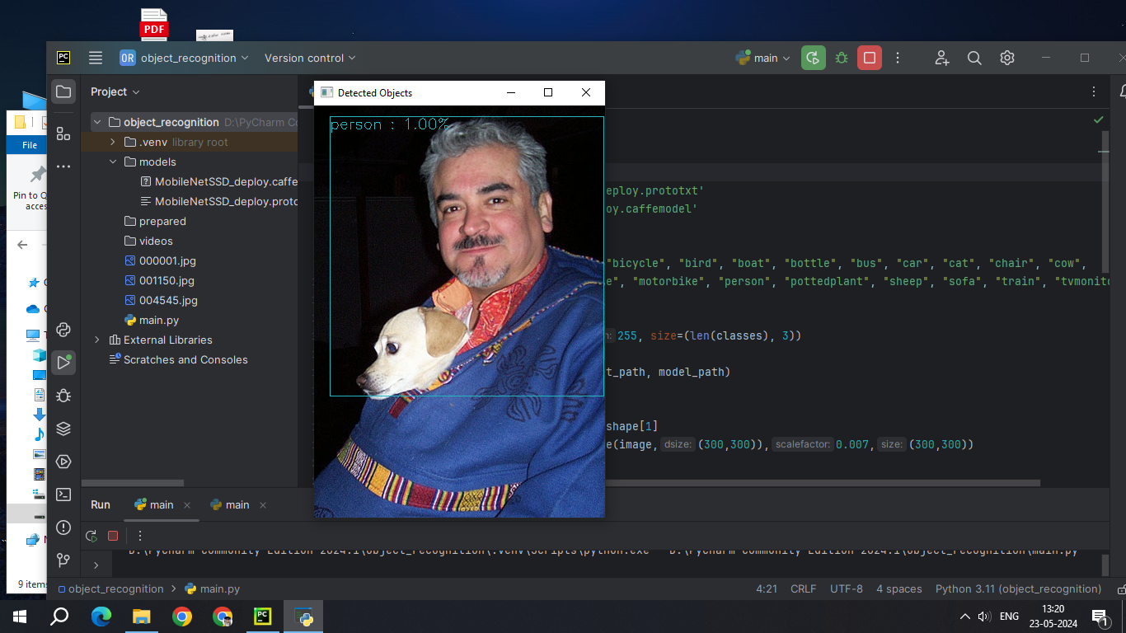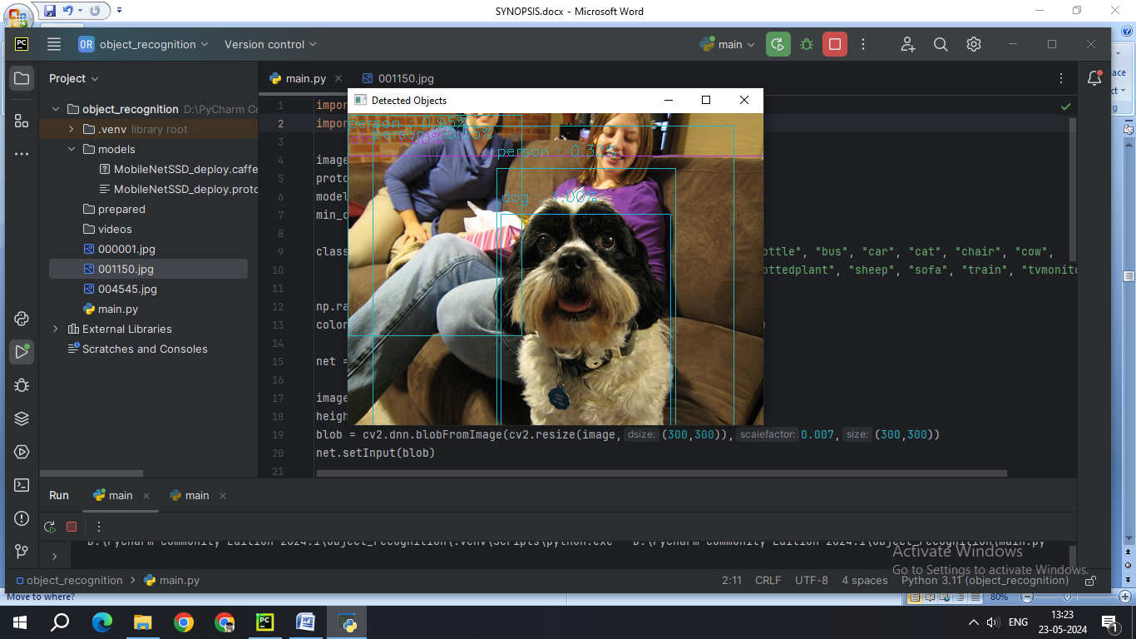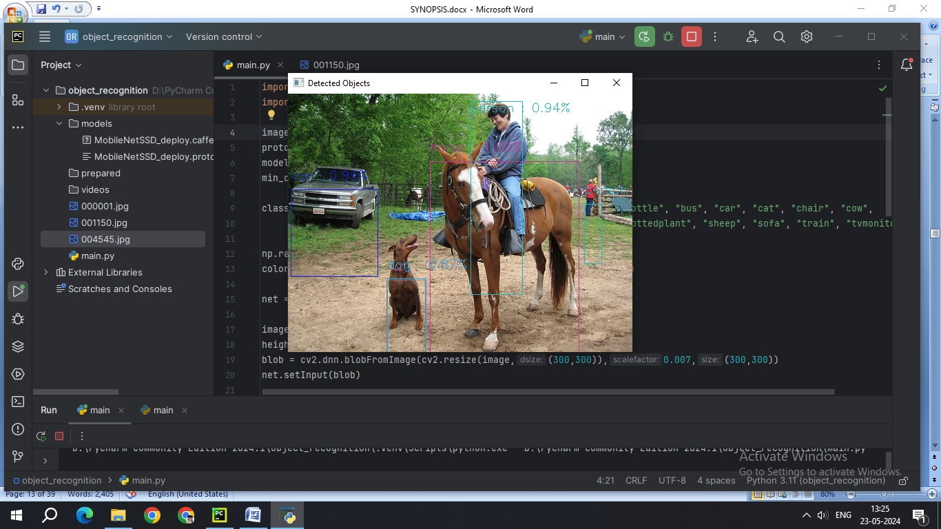

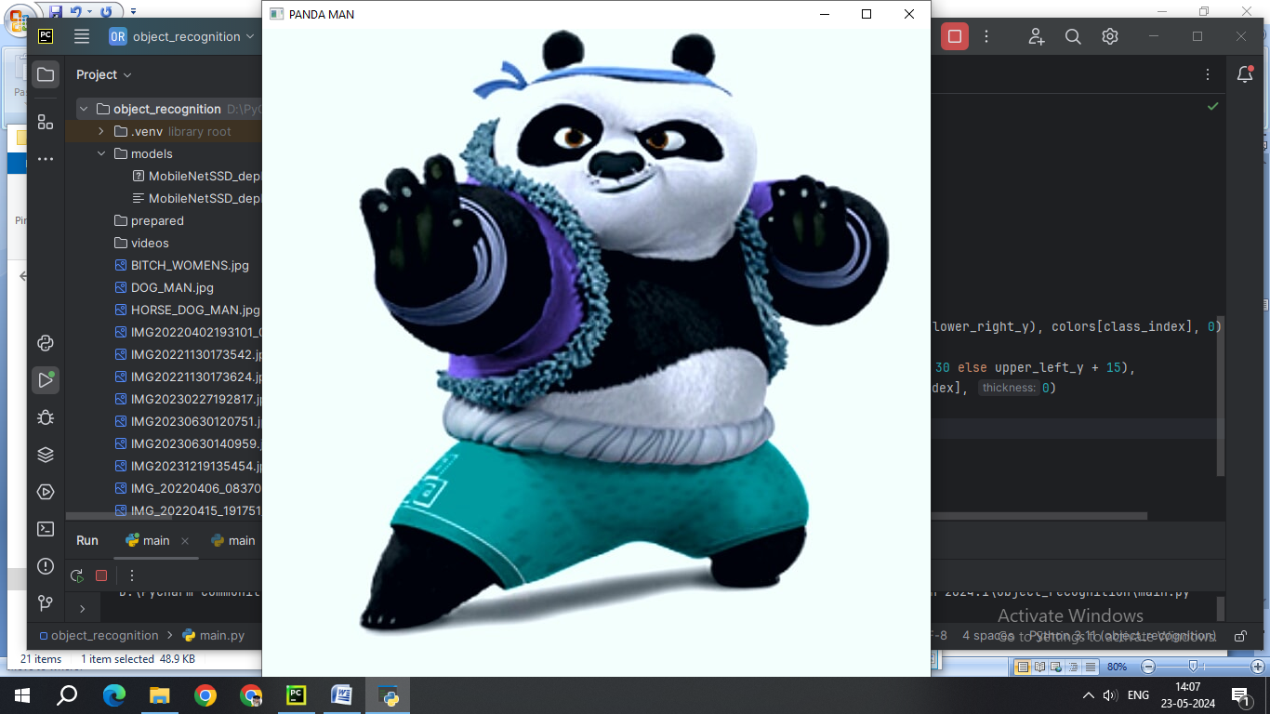

NO DETECTION OF THE PANDA_MAN BECAUSE ITS ILLUSORY

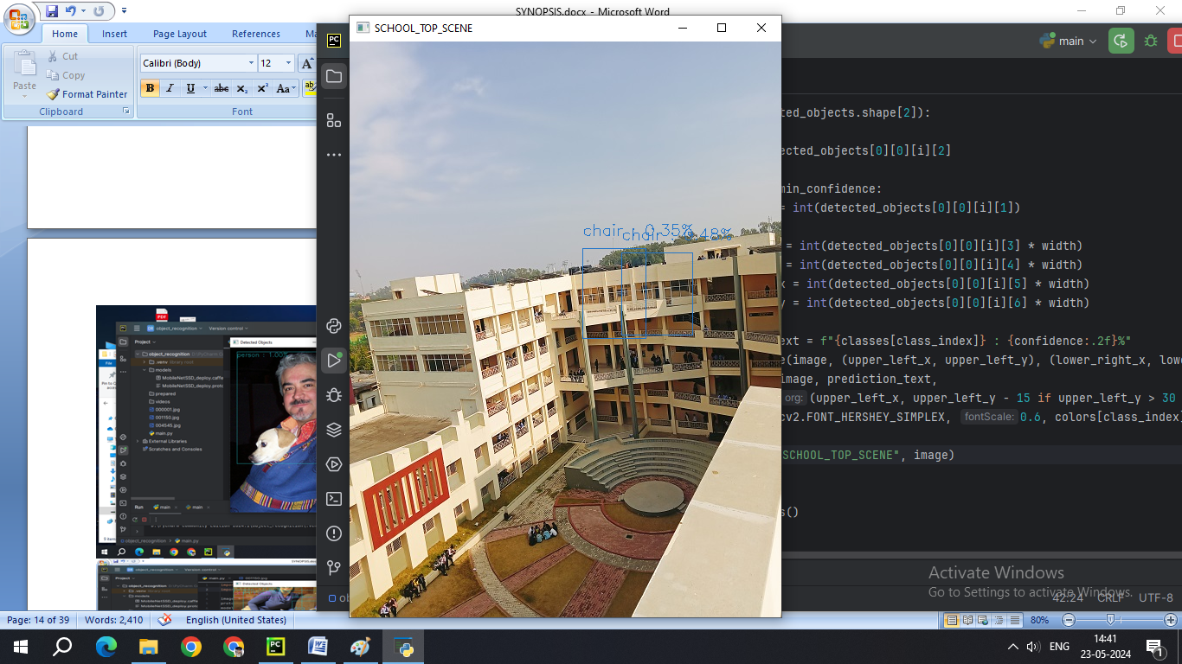

DUE TO THE SIMILAR STRUCTURE THE BUILDING BLOCKS LOOKS LIKE CHAIRS .

THE ACCURACY IS CORRECT AND IN BETWEEN 0.35% TO 0.48%

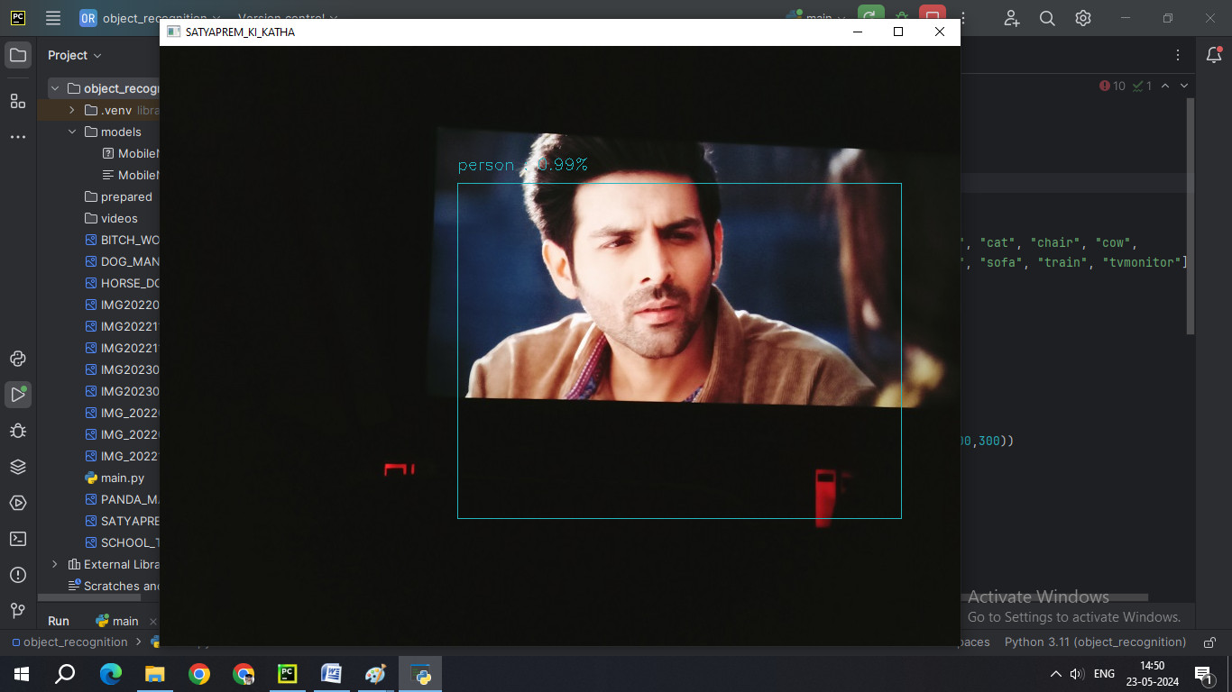

The Picture was ILLUSORY But The CHARACTERS ARE HUMANE. AND WITH 0.99% PRECISION.

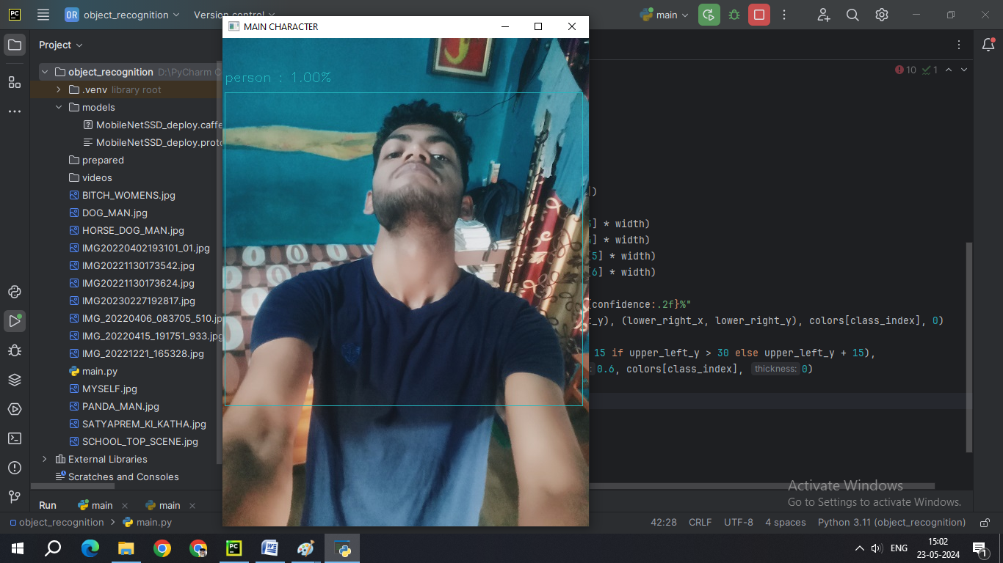

A 100% Accuracy in detection of Human Being .

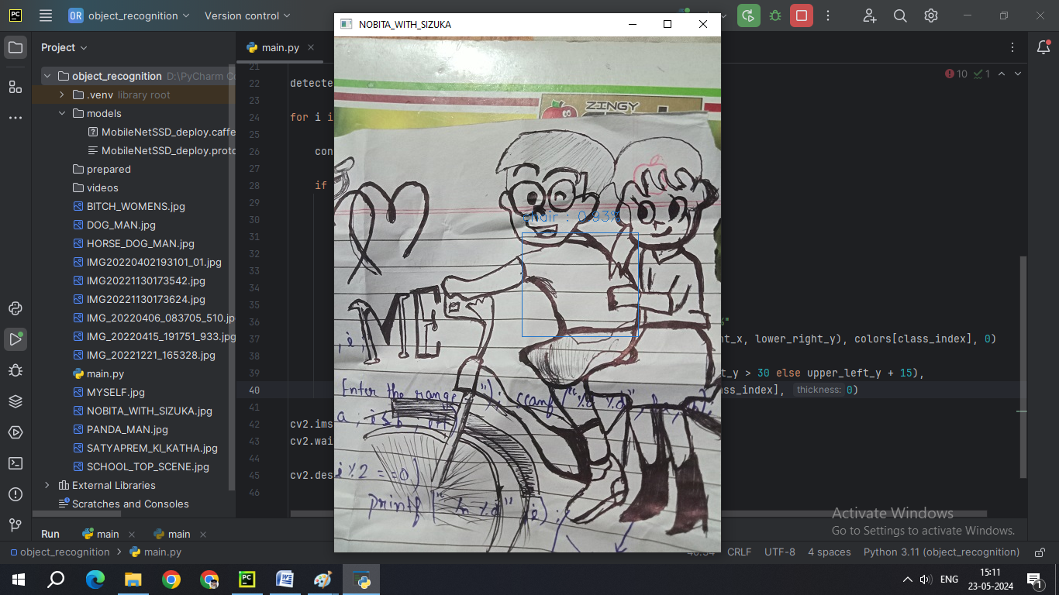

DRAWINGS WHEN PROCESSED GAVE RARE ERRORS. THE DETECTIONS ON DRAWINGS HAVE LOW POSSIBILITIES.

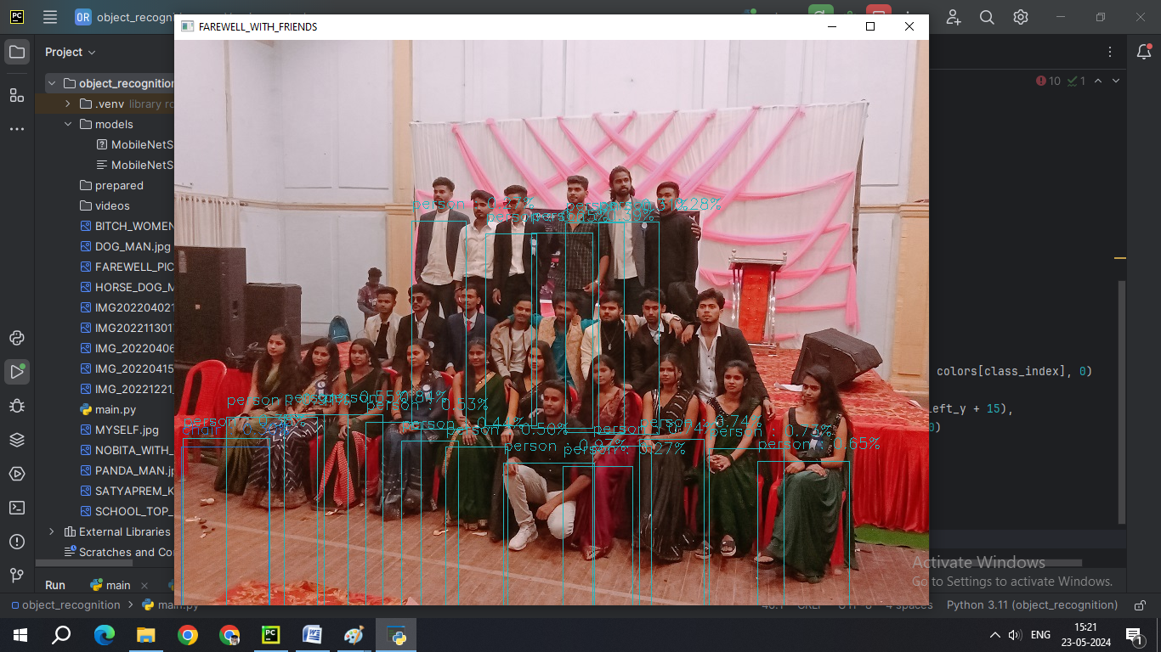

MULTIPLE HUMAN DETECTION. AVERAGE ACCURACY LESS THAN 40%.

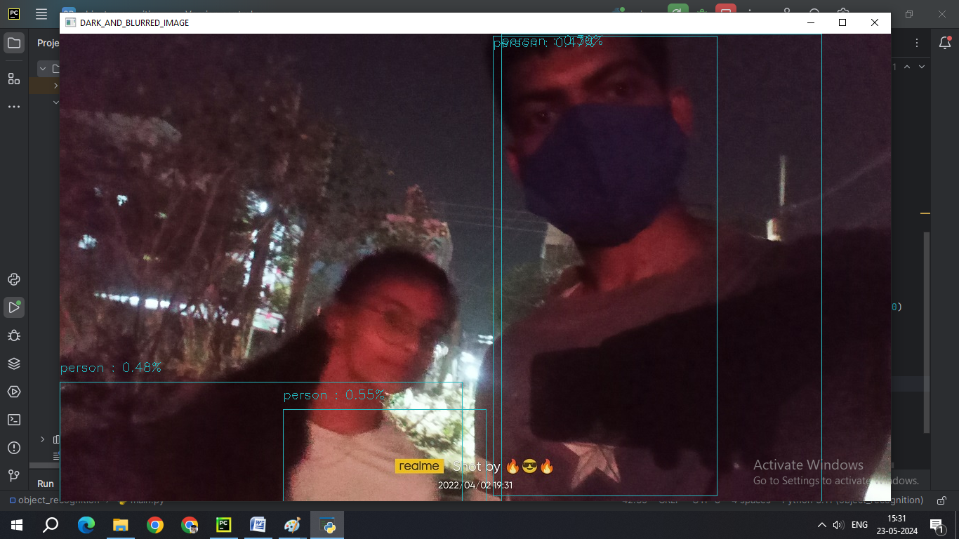

DARK LIGHT AND BLURRED IMAGES OBJEC T DETECTION. ACCURACY RESULTED BELOW 0.50%.

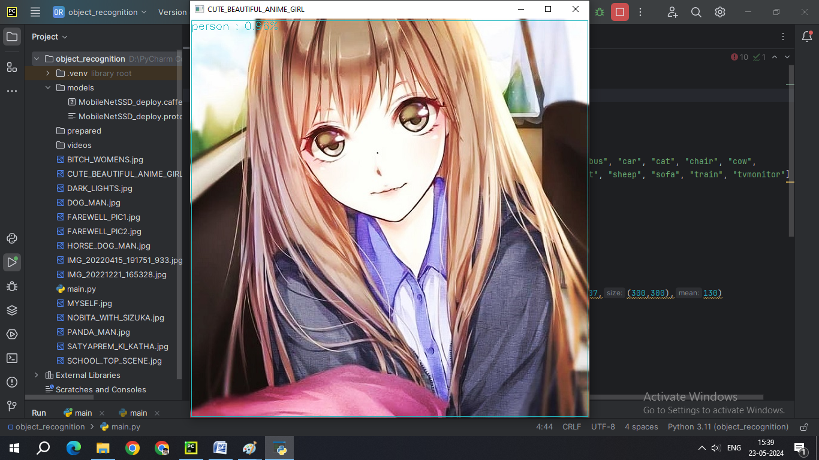

NOT EXPECTED ,BUT ANIMATED PICTURES OF HUMAN BEINGS HAVE GIVEN MORE ACCURACY OF BEING A HUMAN BEING. ANIME PICTURE GOT AN ACCURACY OF 98%.

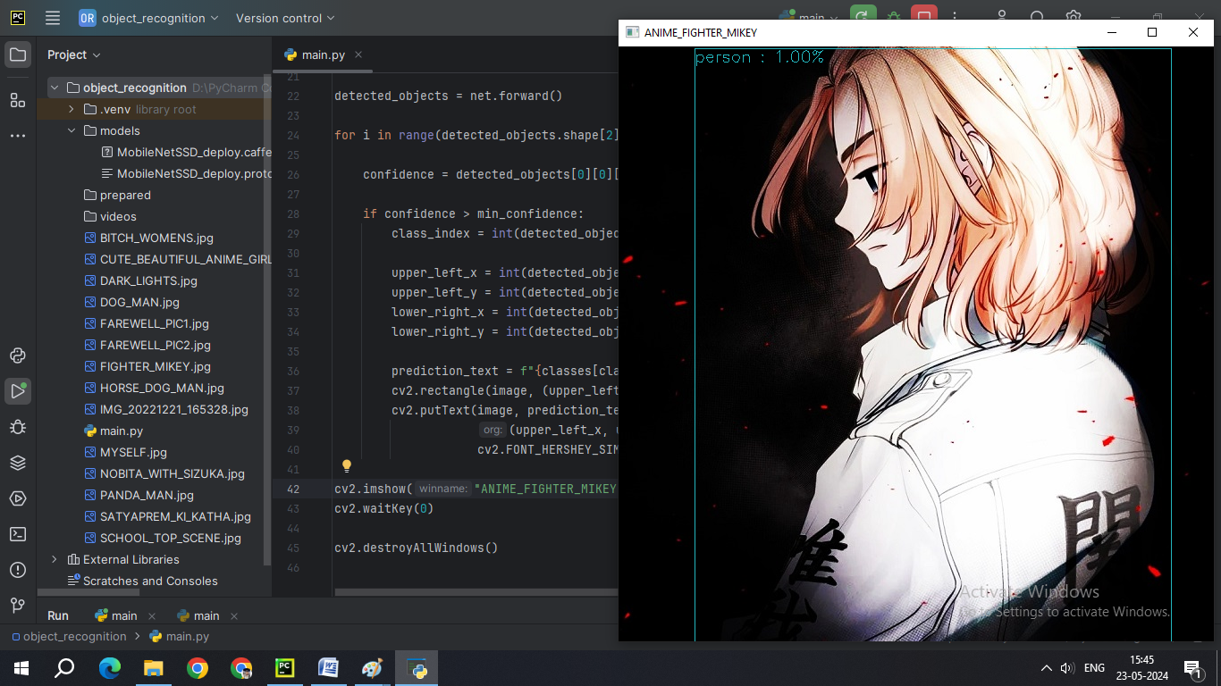

ANOTHER EXAMPLE OF ANIME PICTURES RESULTED IN AN 100% ACCURACY IN HUMAN TESTING.

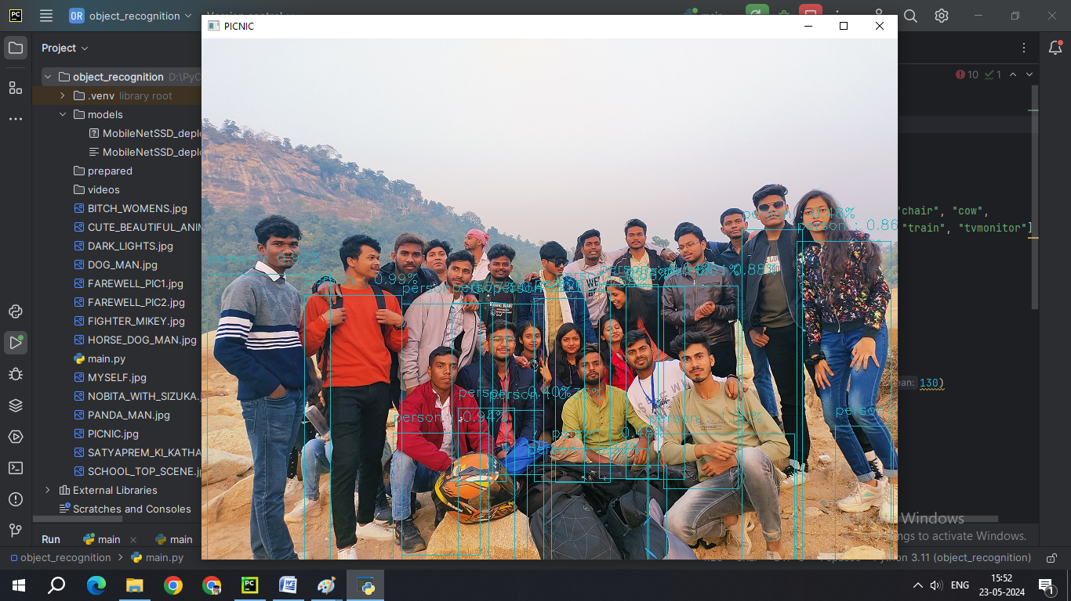

DUE TO PROPER LIGHTING IN THE IMAGE, THE ACCURACY WENT TO 87%. LIGHTENING ALSO AFFECT THE OBJECT DETECTION.

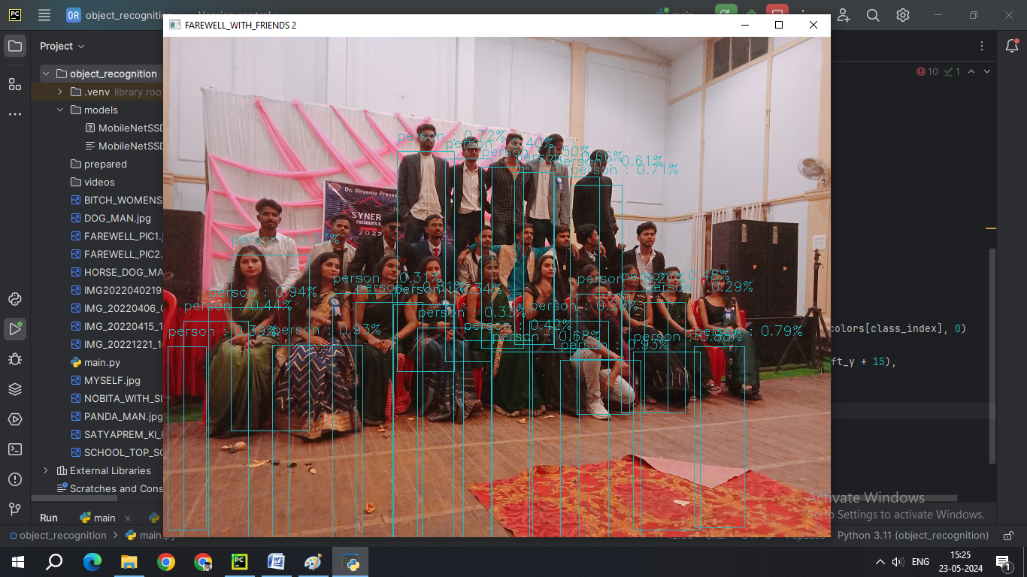

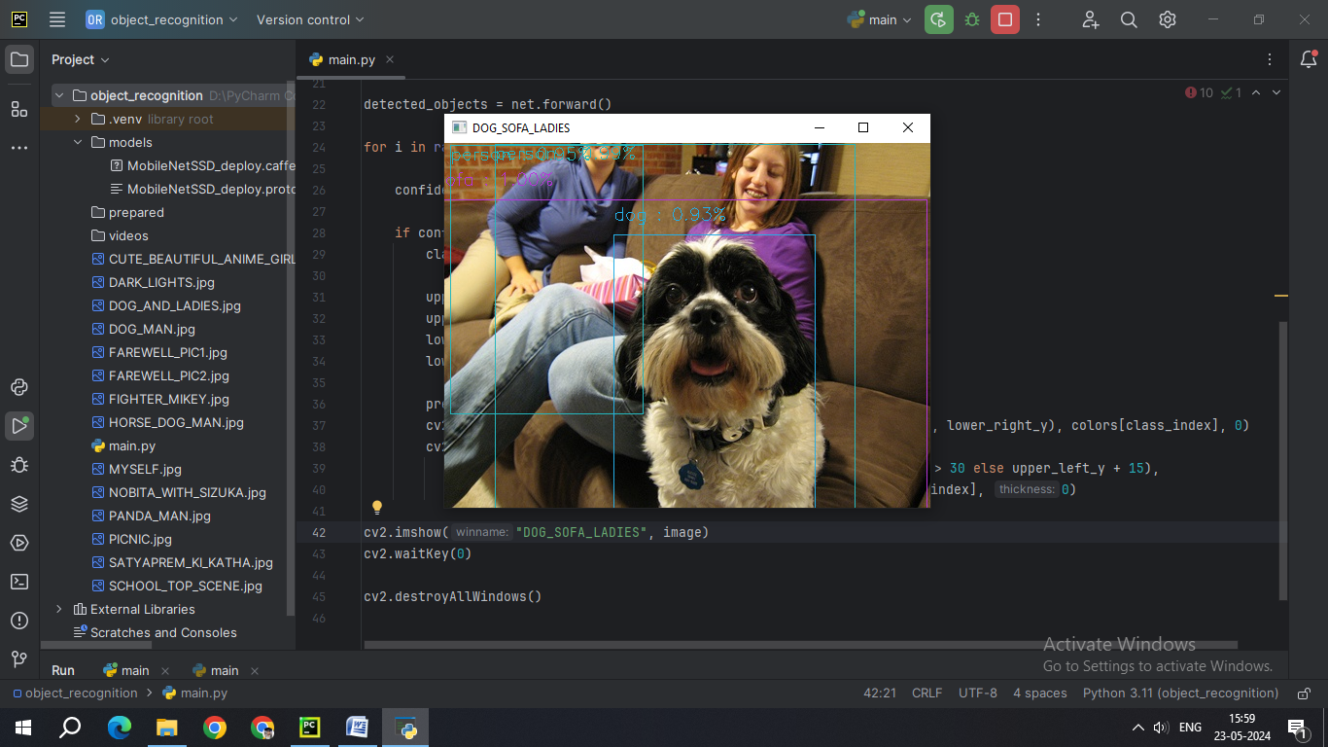

DOG 0.93% , SOFA 1.0% AND TWO WOMENS 0.99% &0.95% ARE DETECTED.